O Come, O Come Emmanuel
A Blue Christmas Service

Welcome to this time when we can, with others, acknowledge the “blue” feelings we have at Christmas time. For many who have lost a loved one, this is a time of sharp loneliness. For others, who have lost a relationship, health, a job, or had a financial setback it may be a time of pain, confusion, or fear. This is not a joyous season for everyone.

You are invited to a brief reception in the Parlor following the service.

Evening Prayer

Officiant Blessed be the God of our salvation.
All Who bears our burdens and forgives all our sins.

In the middle of the night, when stark night was darkest, then you chose to come. God’s resplendent first-born sent to make us one.

The voices of doom protest: “All these words about justice, love and peace—all these naïve words will buckle beneath the weight of a reality which is brutal and bitter, ever more bitter.”

It is true, Lord, it is midnight upon the earth, moonless night and starved of stars. But can we forget that You, the son of God, chose to be born precisely at midnight?
– Dom Helder Camara
Officiant Let us pray.
God of Mercy, hear out prayer in this Advent Season for ourselves and our families who live with painful experiences of loss. We ask for strength for today, courage for tomorrow and peace for the past. We ask these things in the name of Christ who entered the world at Christmas to share our life in sorrow and joy, death and new birth, despair and promise.
All Amen.

The candles at the Altar are now lighted.

First Candle
We light this candle to remember those persons who have been loved and lost. We pause to remember their names, their faces, their voices.

Silence

We give thanks for the memory that binds them to us this season that anticipates Christ.
All May God’s eternal love surround them.

Second Candle
We light this second candle to redeem the pain and loss – the loss of relationships, the loss of health, the loss of jobs, and the loss of financial security. As we gather up the pain of the past, we offer it to you, O God, asking that into our welcome hearts and open hands, you place the gift of peace.
All Refresh, restore, renew us, Oh God, and lead us into Your future.

Third Candle
We light this third candle to remember ourselves this Christmas time. We pause and remember the past weeks, months and for some of us, years of down times. We remember the poignancy of memories, the grief, the sadness, the hurts, and the pain of reflecting on our own mortality.
All Let us remember that dawn defeats darkness.

Fourth Candle
This fourth candle is lit to remember our faith and the gift of hope that God offers to us in the Christmas story. We remember that God, who shares our life, promises us a place and time of no more pain and suffering.
All Let us remember the one who shows the way and who goes with us into our tomorrows.

The Officiant invites all to write on paper the names of those who have been lost or experiences of loss and pain that are weighing on their hearts and minds. People in the congregation may come forward, place their written prayers in the offering basket on the altar, and light candles for these prayers.
Once all have returned, all sing O Come, O Come Emmanuel.

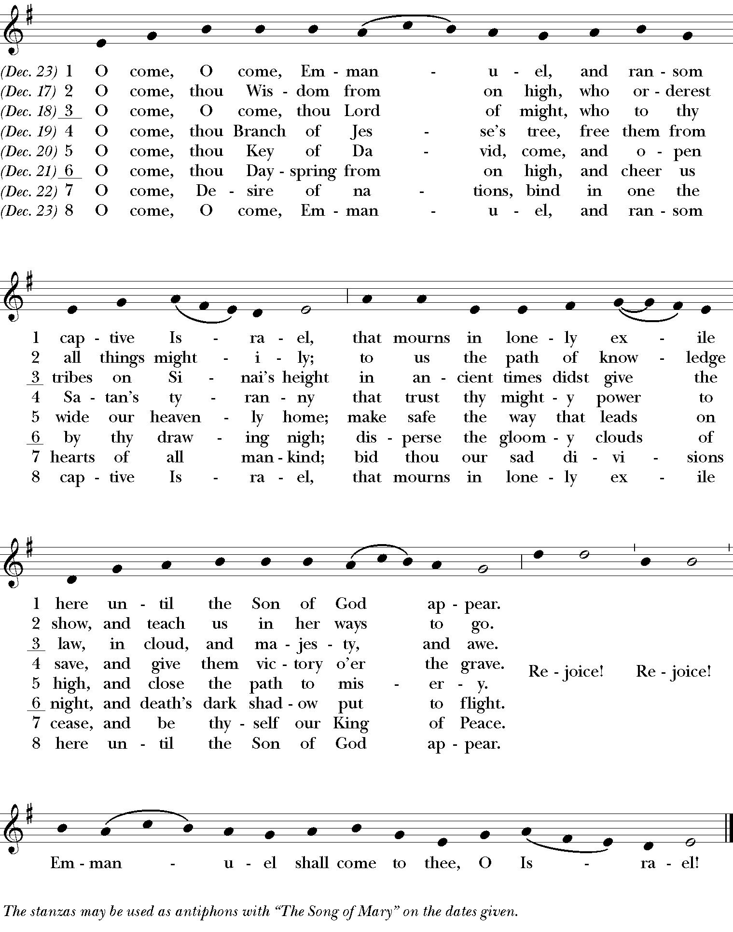
The Psalm (seated) Psalm 139:1-17
All pray a portion of Psalm 139 in unison

Lord, you have searched me out and known me; *

you know my sitting down and my rising up;

you discern my thoughts from afar.

You trace my journeys and my resting-places *
and are acquainted with all my ways.

Indeed, there is not a word on my lips, *
but you, O Lord, know it altogether.

You press upon me behind and before *
and lay your hand upon me.

Such knowledge is too wonderful for me; *
it is so high that I cannot attain to it.

Where can I go then from your Spirit? *
where can I flee from your presence?

If I climb up to heaven, you are there; *
if I make the grave my bed, you are there also.

If I take the wings of the morning *
and dwell in the uttermost parts of the sea,

Even there your hand will lead me *
and your right hand hold me fast.

If I say, “Surely the darkness will cover me, *
and the light around me turn to night,”

Darkness is not dark to you; the night is as bright as the day; *
darkness and light to you are both alike.

For you yourself created my inmost parts; *
you knit me together in my mother’s womb.

I will thank you because I am marvelously made; *
your works are wonderful, and I know it well.

My body was not hidden from you, *
while I was being made in secret and woven in the depths of the earth.

Your eyes beheld my limbs, yet unfinished in the womb;
all of them were written in your book; *
they were fashioned day by day, when as yet there was none of them.

How deep I find your thoughts, O God! *
how great is the sum of them!

If I were to count them, they would be more in number than the sand; *
to count them all, my life span would need to be like yours.

Glory to the Father, and to the Son, and to the Holy Spirit *
as it was in the beginning, is now, and will be for ever. Amen.

The Lessons (seated)
First Reading Isaiah 9:2, 6-7

Reader A reading from the Book of the Prophet Isaiah

The people who walked in darkness have seen a great light; those who lived in a land of deep darkness— on them light has shined. For a child has been born for us, a son given to us; authority rests upon his shoulders; and he is named Wonderful Counselor, Mighty God, Everlasting Father, Prince of Peace. His authority shall grow continually, and there shall be endless peace for the throne of David and his kingdom. He will establish and uphold it with justice and with righteousness from this time onward and forevermore. The zeal of the Lord of hosts will do this.

Reader Hear what the Spirit is saying to the Church.
All Thanks be to God.

Silence

Canticle: A Song of Christ’s Goodness Anselm of Canterbury

Jesus, as a mother you gather your people to you; *
you are gentle with us as a mother with her children.

Often you weep over our sins and our pride, *
tenderly you draw us from hatred and judgment.

You comfort us in sorrow and bind up our wounds, *
in sickness you nurse us and with pure milk you feed us.

Jesus, by your dying, we are born to new life; *
by your anguish and labor we come forth in joy.

Despair turns to hope through your sweet goodness; *
through your gentleness, we find comfort in fear.
Anselm of Canterbury (c. 1033 – 21 April 1109) a Benedictine monk, a philosopher, and Archbishop of Canterbury from 1093 to 1109.
Your warmth gives life to the dead, *
your touch makes sinners righteous.

Lord Jesus, in your mercy, heal us; *
in your love and tenderness, remake us.

In your compassion, bring grace and forgiveness, *
for the beauty of heaven, may your love prepare us.

Silence

Second Reading (seated) Luke 2:1-7

Reader A reading from the gospel according to Luke

In those days a decree went out from Emperor Augustus that all the world should be registered. This was the first registration and was taken while Quirinius was governor of Syria. All went to their own towns to be registered. Joseph also went from the town of Nazareth in Galilee to Judea, to the city of David called Bethlehem, because he was descended from the house and family of David. He went to be registered with Mary, to whom he was engaged and who was expecting a child. While they were there, the time came for her to deliver her child. And she gave birth to her firstborn son and wrapped him in bands of cloth, and laid him in a manger, because there was no place for them in the inn.

Reader Hear what the Spirit is saying to the Church.
All Thanks be to God.

Silence

Canticle: A Song of Our True Nature Julian of Norwich

Christ revealed our frailty and our falling, *
our trespasses and our humiliations.

Christ also revealed his blessed power, *
his blessed wisdom and love.

He protects us as tenderly and as sweetly when we are in greatest need; *
he raises us in spirit and turns everything
to glory and joy without ending.

God is the ground and the substance, the very essence of nature; *
God is the true father and mother of natures.

We are all bound to God by nature, *
and we are all bound to God by grace.
Julian of Norwich (c. November 8, 1342 – c. 1416) is thought of as one of the greatest English mystics. Little is known of her life aside from her writings.

And this grace is for all the world, *
because it is our precious mother, Christ.

For this fair nature was prepared by Christ
for the honor and nobility of all,
and for the joy and bliss of salvation.

Silence

Third Reading (seated) Wild Geese by Mary Oliver

You do not have to be good.
You do not have to walk on your knees
for a hundred miles through the desert, repenting.
You only have to let the soft animal of your body
love what it loves.
Tell me about despair, yours, and I will tell you mine.
Meanwhile the world goes on.
Meanwhile the sun and the clear pebbles of the rain
are moving across the landscapes,
over the prairies and the deep trees,
the mountains and the rivers.
Meanwhile the wild geese, high in the clean blue air,
are heading home again.
Whoever you are, no matter how lonely,
the world offers itself to your imagination,
calls to you like the wild geese, harsh and exciting –
over and over announcing your place
in the family of things.

Reader Hear what the Spirit is saying to the Church.
All Thanks be to God.

Homily (seated) The Rector

Affirmation of Faith (Standing, as able)
Officiant Let us declare our faith in God.

All say together

We believe in God, the Father,
from whom every family
in heaven and on earth is named.

We believe in God the Son,
who lives in our hearts through faith,
and fills us with his love.

We believe in God the Holy Spirit,
who strengthens us
with power from on high.
cf Ephesians 3, Affirmation of Faith from Common Worship of the Church of England

We believe in one God,
Father, Son and Holy Spirit.
Amen.

The Prayers (standing, as able)
Leader In the spirit of this season let us now confidently ask God for what we need. We pray, as well, for ourselves as we participate in whatever way we can this Christmas.

All are invited to offer their prayers aloud or silently

Leader God hear our Prayer
All And in your mercy answer.

Leader For our families and friends that they may know love and peace and happiness in you and that they may continue to help and support us.

All are invited to offer their prayers aloud or silently for families and friends

Leader God hear our Prayer
All And in your mercy answer.

Leader For those we have loved who have died. For all the losses that we know, that all may be redeemed by your Easter promise.

All are invited to offer their prayers aloud or silently for those who have died

Leader God hear our Prayer
All And in your mercy answer.

Leader For the peace proclaimed by the Christmas angels, to come throughout the whole world.

All are invited to offer their prayers aloud or silently for our region and world

Leader God hear our Prayer
All And in your mercy answer.

Leader God of great compassion and love, listen to the prayers of these your people. Grant to all, especially all who are bereaved and saddened this Christmas, the blessing we ask in the name of Christ who taught us to pray together saying

All Our Father, who art in heaven, hallowed be thy Name, thy kingdom come, thy will be done, on earth as it is in heaven. Give us this day our daily bread. And forgive us our trespasses, as we forgive those who trespass against us. And lead us not into temptation, but deliver us from evil. For thine is the kingdom, and the power, and the glory, for ever and ever. Amen.

Collect of the Day
Purify our conscience, Almighty God, by your daily visitation, that your Son Jesus Christ, at his coming, may find in us a mansion prepared for himself; who lives and reigns with you, in the unity of the Holy Spirit, one God, now and for ever.
All Amen.

A Collect for Protection
O God, the life of all who live, the light of the faithful, the strength of those who labor, and the repose of the dead: We thank you for the blessings of the day that is past, and humbly ask for your protection through the coming night. Bring us in safety to the morning hours; through him who died and rose again for us, your Son our Savior Jesus Christ.
All Amen.

A Collect for Peace
Most holy God, the source of all good desires, all right judgments, and all just works: Give to us, your servants, that peace which the world cannot give, so that our minds may be fixed on the doing of your will, and that we, being delivered from the fear of all enemies, may live in peace and quietness; through the mercies of Christ Jesus our Savior.
All Amen.

Hymn Silent Night (standing, as able)

¹ Silent night, holy night,
all is calm, all is bright
round yon virgin mother and child.
Holy infant, so tender and mild,
sleep in heavenly peace.

² Silent night, holy night,
shepherds quake at the sight,
glories stream from heaven afar,
heavenly hosts sing alleluia;
Christ, the Savior, is born!

³ Silent night, holy night,
Son of God, love’s pure light
radiant beams from thy holy face,
with the dawn of redeeming grace,
Jesus, Lord, at thy birth.

Officiant Let us bless the Lord.
All Thanks be to God.

Officiant  May the God of hope fill us with all joy and peace in believing through the power of the Holy Spirit.
All Amen.

You are invited to gather for refreshments in the parlor.

