“BLUE CHRISTMAS”

A Community Service at Christmas
for Grieving, Praying, and Healing

December 11, 2008


St. Gabriel's Episcopal Church

Extraordinary Welcome
Deep Healing
Venturing Love

15717 Stephens Drive, Eastpointe, Michigan 48021
Office: 586-775-4450 Fax: 586-775-4640
E-mail: stgabrielseastpointe@yahoo.com
Webpage: www.stgabrielseastpointe.org
Whoever you are, wherever you come from,
we warmly welcome you to St. Gabriel’s Church.

This service will give us the chance to express the grief, fears, anger,
and confusion that are a normal part of living and loving.

In worship, we will ask God for healing, and become again, ever-so-gently, ready to face a future sustained by hope and grace.

Please write your sorrow, your loss, your concern, your prayer, or your hope on the index card provided and place it in the basket at the front. It will be read aloud for you during the service.

You will also have the chance to light a candle for, and name, someone you have lost and especially miss this Christmas.

You’re invited to stand as indicated,
and to join the service by saying the parts written in bold.

However, it’s most important that you do what you need to do to facilitate your healing. So please sit, remain silent, weep, or even pace,
as you feel the need throughout this worship service.
There are people here who will sustain you
with their singing, praying, and healing love.

The Laying-on of Hands for Healing.

This is a very old practice of the Church, and offers strength, comfort, and healing through the gift of touch and prayer. You may ask for healing, physical, spiritual, or emotional, for yourself or someone else.

You may tell the ministers what you are asking God for, or you may remain silent
and they will pray with the Spirit’s wisdom.

Song: “Precious Lord”

Your grief, O God, is as eternal as your love. You, yourself, weep for us in our sadness. The sorrow in our lives is felt in your own heart, as you always reach towards us in compassion. Reach for us now, and be our very present help in this time of deep trouble. Speak to us, God; comfort, heal, and restore us. Amen.

A Reading from Psalms 6 and 34

Have pity on me, Lord, for I am weak; heal me, Lord, for my bones are racked.
My spirit shakes with terror; how long, O Lord, how long?

I grow weary because of my groaning;
every night I drench my bed with tears.
My eyes are wasted with grief .

I sought the Lord, and he answered me and delivered me out of all my terror.
Look upon him and be radiant, and let not your faces be ashamed.

I called in my affliction and the Lord heard me
and saved me from all my troubles.
The angel of the Lord encompasses those who fear him,
and he will deliver them.

Taste and see that the Lord is good; happy are they who trust in him!
The eyes of the Lord are upon the righteous, and his ears are open to their cry.

The righteous cry, and the Lord hears them
and delivers them from all their troubles.
The Lord is near to the brokenhearted
and will save those whose spirits are crushed.

Many are the troubles of the righteous, but the Lord will deliver him out of them all.

Song: “In his time”

This song will be sung several times, with some of your cards being read throughout.

A Reading from Isaiah

Do not fear, for I have redeemed you; I have called you by name, you are mine. When you pass through the waters, I will be with you; and through the rivers, they shall not overwhelm you; when you walk through fire you shall not be burned, and the flame shall not consume you. Because you are precious in my sight, and honored, and I love you, I give people in return for you, nations in exchange for your life. Do not fear, for I am with you.

Thus says the Lord, who makes a way in the sea, a path in the mighty waters. Do not remember the former things, or consider the things of old. I am about to do a new thing; now it springs forth, do you not perceive it? I will make a way in the wilderness and rivers in the desert.

For I give water in the wilderness, rivers in the desert, to give drink to my chosen people, the people whom I formed for myself so that they might declare my praise.

Psalm 23

The Lord is my shepherd; I shall not want.
He maketh me to lie down in green pastures;
he leadeth me beside the still waters.
He restoreth my soul;
he leadeth me in the paths of righteousness
for his Name’s sake.
Yea, though I walk through the valley
of the shadow of death,
I will fear no evil; for thou art with me;
thy rod and thy staff, they comfort me.
Thou preparest a table before me
in the presence of mine enemies;
thou anointest my head with oil;
my cup runneth over.
Surely goodness and mercy
shall follow me all the days of my life,
and I will dwell in the house of the Lord for ever.
Song: “Amazing grace”

1 Amazing grace! how sweet the sound, that saved a wretch like me!
I once was lost but now am found, was blind but now I see.

2 ’Twas grace that taught my heart to fear, and grace my fears relieved;
how precious did that grace appear the hour I first believed!

3 The Lord has promised good to me, his word my hope secures;
he will my shield and portion be as long as life endures.

4 Through many dangers, toils, and snares, I have already come;
’tis grace that brought me safe thus far, and grace will lead me home.

5 When we’ve been there ten thousand years, bright shining as the sun,
we’ve no less days to sing God’s praise than when we’d first begun.

Homily: The Rev. Susan K. Bock

The Prayers Other cards you have written will be read during these prayers.

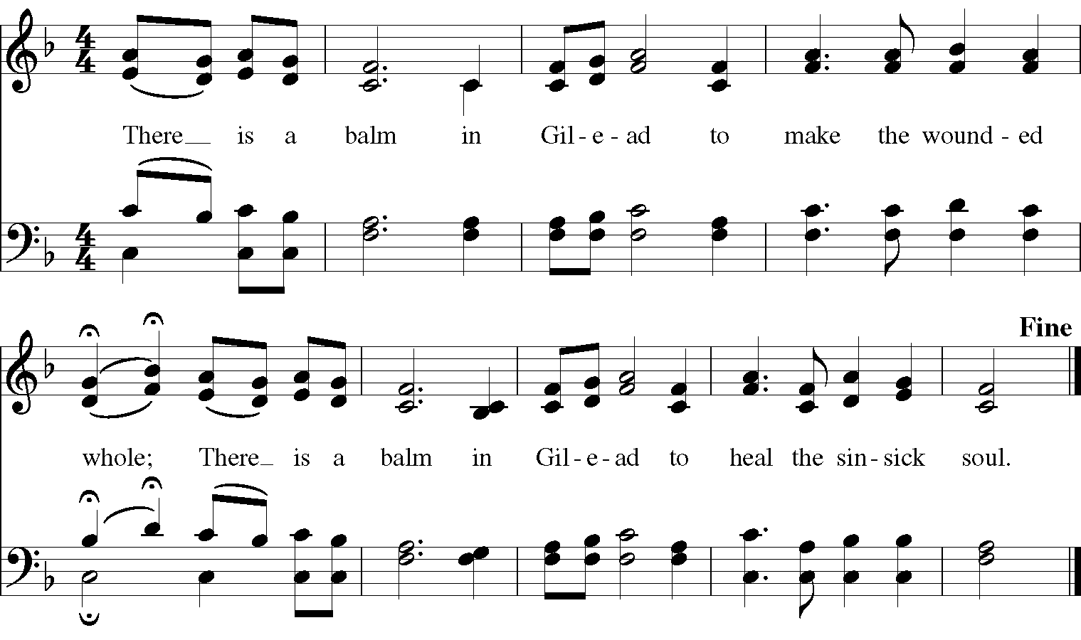

Compassionate God, you know our deepest longings and sorrows. Hear our sorrow and let our cry come to you.
Stand near in the darkness, O God.

We are broken by our loss and afraid of our future, overwhelmed by all we cannot understand.
Stand near in the darkness, O God.

We are heavy with sadness and grief, sick with despair, aching with emptiness;
Stand near in the darkness, O God.

We are confused and enraged at what feels unjust. We are frightened to find ourselves doubting your love;
Stand near in the darkness, O God.

Turn your heart towards us, healing God. We have lost our way and feel alone in our sorrow.
Turn your heart towards us and let mercy flow.

Help us to grieve honestly and bravely, allowing our tears to fall freely.
Turn your heart towards us and let mercy flow.

Teach us to trust you with all that we feel and for all that we need.
Turn your heart towards us and let mercy flow.
Release us from blame towards others or ourselves. Forgive us our failures at love.
Turn your heart towards us and let mercy flow.

Heal us of shame and guilt; save us from regret.
Turn your heart towards us and let mercy flow.

Give us grace to endure, and the courage of love in all that we do.
Turn your heart towards us and let mercy flow.

Save and restore us, Good Lord, by your love. Only you can heal us.
Send your life-giving Spirit to renew our broken hearts.
Save and restore us, Good Lord, by your love.

Increase our patience toward ourselves and each other.
Save and restore us, Good Lord, by your love.

Help us let go of lost dreams, and entrust ourselves to your purpose and will.
Save and restore us, Good Lord, by your love.

Use our sorrows to enlarge our compassion toward others and ourselves.
Save and restore us, Good Lord, by your love.

Release us from fear, renew us in love, and rekindle our hope.
Save and restore us, Good Lord, by your love.

Fill us with thanks for the good things we enjoy, help us to notice our blessings.
Save and restore us, Good Lord, by your love.

Help us remember, always, those who suffer in illness, war, poverty, or despair,
and turn our hearts towards their relief.
Save and restore us, Good Lord, by your love.

Renew us this night, that we might live as your children in the strength of your love.

Gracious God, as a father has compassion on his children, as a mother carries and feeds her children, so do you have mercy on us, and carry us in our afflictions. We thank you for strengthening and renewing us in your love. We pray for grace to help you push back the darkness in our world, to help unfold your light, and to live with courage, kindness, and hope. Amen.

A Reading from John of the Cross: “Even in the Night”

Surely I know the spring that swiftly flows
Even during the night.

That everlasting spring is deeply hidden,
But surely I know the place where it begins,
Even during the night.

I don’t know its source, because it has none.
But I know that all beginnings come from this one,
Even during the night.

I do know that nothing can equal its beauty
And that from it both heaven and earth drink
Even during the night.

I know there is no limit to its depth
And that no one can wade across its breadth,
Even during the night.
Its brightness is never clouded over,
And I know that from it all light flows,
Even during the night.

I know its current is so forceful
That it floods the nations, heaven, and hell
Even during the night.

The current that is born of this stream,
I know, is powerful and strong
Even during the night.

The living stream that I so desire,
I see in the bread of life,
Even during the night.

Song: “It is well with my soul”

During this song, please come forward to light a candle for a beloved person you have lost to death. You may also go to the prayer station for the laying-on of hands.

Clergy:
Susan Bock, Pastor Betty Brogan, Deacon
Minister of Music:
Gerald Furi

Sunday Morning Schedule
8:30 a.m . Traditional Service
9:30 a.m . Coffee Hour and Adult Education
10:30 a.m. Contemporary Service, with Healing,
Sunday School for children and teens

Christmas Eve Worship
5:00 and 10:30 p.m.

